Spring Wheat Crop Yield Prediction Model

CIND820: Capstone Project

Submitted by: Nadji Bessa

e./ [nadji.bessa@torontomu.ca](mailto:nadji.bessa@torontomu.ca)

Student Number: 944 363 324

Date of submission: Monday November 27, 2023

Supervisor: Ceni Babaoglu

**Table of Contents**

**Abstract 3**

**Literature Review 5**

The Influence of Climate Change on Global Crop Productivity 5

Impacts of climate change and climate extremes on major crops productivity in China at a global warming of 1.5◦ and 2◦C. 6

The impacts of climate change on crops in China: A Ricardian analysis 7

Regional climate change impacts on agricultural crop production in Central and Eastern Europe – hotspots, regional differences and common trends 8

Climate change impacts and adaptations for wheat employing multiple climate and crop models in Pakistan 10

Comparing simulated crop yields with observed and synthetic weather data. 11

**Outline of Literature Review Conclusions 13**

**Preliminary Analysis 14**

Data Quality 14

Government of Ontario Spring Wheat crop data (see Appendix A) 14

Government of Canada historical weather data 14

**Final Results 15**

Correlation Table 20

Conclusions 21

**References 23**

**Appendix A - Datasets 25**

# 

# Abstract

One of the areas in which climate change will have the most impact is farming, and with that our ability to continue to maintain adequate food supply to sustain our civilization.

The most obvious symptoms of Climate Change is extreme weather (i.e. floods, droughts, etc…) and it is easy to see their direct impact on agriculture, but what about more subtle yet permanent changes in weather patterns that constitute the new normal as a new climate change pattern sets in?

To date, most literature seem to support the notion that climate change will usher in a scenario where elevate average will increase growing seasons in some areas of the world, while in others increase the likelihood of heat stress, drought or flood.

How is temperature and rainfall affecting crop production? In other words, can we, by studying temperature and precipitation, outline optimal growing conditions for commercial crops and develop a model to predict the impact of those two variables will have on future agricultural production?

Again, most of the literature support the notion that with increased CO2 level, there will be elevated temperature (which in itself is a pretty important determinant of crop yield due to its effect on the optimal photosynthesis process of each crop ), but temperature affects water availability or excess and that is also an important determinant in crop development.

In this capstone project, the scope of our analysis will be on one crop: Spring wheat. Wheat is used to make a wide range of foods including bread, crumpets, muffins, noodles, pasta, biscuits, cakes, pastries, cereal bars, sweet and savory snack foods, crackers, crisp-breads, etc.

Using wheat production as well as related temperature and precipitation data from the province of Ontario (see Appendix A), we will study and determine optimal wheat production.

Subsequently we will also explore several machine learning algorithms and their performance in accurately predicting wheat agricultural output based on temperature and rainfall during a given growing season.

So far most of the literature seem to indicate that wheat is sensitive to extreme heat and arid conditions, so it would seem at least that in other studies, in scenarios where climate change usher warmer conditions during winter/spring, there would be a positive effect on wheat yield; As for summer summer/fall wheat production if climate change would bring about droughts or extreme heat then that would have a negative impact on yield results.

Examining temperature and rainfall is a very simplified approach since a literature review has outlined how elevated C02 has a cascading effect on temperature, which in turn affects water availability. C02 fertilization effect and its ability to enhance crop photosynthesis, soil moisture, temperature minimums and maximums during crop development; water vapor are really the parameter that would provide a more accurate study of the impact of climate change on crop yield.

# Literature Review

## The Influence of Climate Change on Global Crop Productivity

The increase in CO2 will undoubtedly increase global temperature, in turn higher temperature levels are expected to have a positive effect on some crops yield while also having the opposite effect on some others. Higher temperatures have a different effect on some crops in some cases (e.g. maize) would benefit from more photosynthesis, as this phenomenon is optimal at a temperature that may or not closely match the new temperature associated with climate change. This means while maize and sugarcane benefit from climate change, rice and wheat may not.

Other determinants are: atmospheric levels of Ozone (O3) and precipitation.

The most observable phenomenons to be associated with climate change are:

* Trends in temperature increases seem to be consistent and it also tends to be linear (roughly around 0.3o C per decade - from 1980 to 2008.
* Although small variation in Temperature may take place globally, regionally there may be more acute changes in changes.
* Growing season has not followed the same linear change as temperature change. It would appear that soil moisture is an important determinant of the growing season and although affected by temperature it does follow its rate of change.
* Temperature increase will coincide with evapotranspiration rates, and along with more intense storms and an associated higher proportion of runoff. This will lead to less overall soil moisture and a higher risk of agricultural drought in many agricultural land areas.
* Higher temperature will cause higher saturation vapor pressure leading to less effective water-use efficiency (because lose more water per unit of carbon gain).
* Higher temperatures will extend in some areas of the world (e.g. Canada, Scandinavia), while causing more heat stress resulting in crop failure in other parts of the world.
* Higher temperature and shift in rain pattern will cause droughts and or flooding both have a negative impact on crop yields.

Amidst these seemingly contradictory reactions to climate change the global production of food should remain to levels presently achieved if technology is used to continue optimizing where certain crops should continue to be grown and farming practices in general. But fundamentally every crop is going to be affected differently by climate change.

In summary, Temperature is a leading indicator of crop yield and that different crops react differently to it. Other determinants such as precipitation are also explored in this paper: C02 and Ozone levels - note these are not under consideration for this project . This would lead us to ascertain that our study is rather simplistic and that in order to make a better analysis and predictions more features (CO2 and O3 levels) should have been in consideration.

## Impacts of climate change and climate extremes on major crops productivity in China at a global warming of 1.5◦ and 2◦C.

The crops under study in this paper are: maize (corn), wheat and rice

Similarly to ‘The Influence of Climate Change on Global Crop Productivity’ article they convey some data points on what we stand to observe as climate change projected effects:

* CO2 fertilization could enhance crop photosynthesis and increase crop productivity for all three major crops - although at different rates for each.
* Climate-related heat stress on major crop yield would affected yield negatively in northern China but not so much in southern China
* Climate-related drought stress on wheat and maize would lead to decreased yields in Northern China but not so much in Southern China

The authors of this paper tried to mitigate uncertainties in their projection by running various simulations using different sets of parameters (from a set of 10) and produced over 70 different scenarios. The scope of their study compared the 2006-2015 period against a fictive 2106-2115 area in which it is assumed that world temperature would have succumbed to a 1.5o to 2o degree increase as a result of Climate change.

The conclusion of this study is that the overall output of crops maize, wheat and rice would overall be the same. While some regions would see increased or adverse reactions to changing climate conditions other areas would see the reversed trends. It is worth noting however that it would seem that a 2o degree scenario would be more beneficial than a 1.5o scenario would.

## The impacts of climate change on crops in China: A Ricardian analysis

The Ricardian analysis is an effective approach for assessing the impact of climate change on agriculture. The Ricardian method was named after David Ricardo, an Italian economist who was the first to note that farm property values reflect the net productivity of the land.

The goal of this paper was to assess the impact of climate change on China’s agricultural production while examining it at the granularity of farm-level data, across all provinces.

Taking 2009 as a representative year from which to establish the parameters of their models, the researchers proceed to use data from 1980 to 2010 as a baseline.

The researcher’s finding is that greater warning in spring was harmful for the net crop revenue per hectare, while a greater warming in the fall and winter was beneficial for improving net revenue per hectare, whereas higher precipitation in the spring and fall resulted in lower net revenue per hectare, while higher precipitation in the summer and winter resulted in higher net revenue per hectare.

Although the impacts of climate change on net crop revenue per hectare at the national level were positive and showed that the risk of climate change is not a concern, at the regional and provincial levels there was significant variance from negative to positive.

A warming climate can reduce the risk of frost damaging crops and increase the potential productivity in the Northeast, Northeast and North regions due to an increase in the

accumulated temperature and the rising rainfall, but the rising rainfall can lead to significant flooding in the Southwest and South Central regions. Therefore, the provinces in the Southwest region will suffer from a significant loss, while the provinces in the Northeast, North and Northwest will benefit significantly from climate change

The regions that suffered the most negative impact were mainly distributed in the Southwest, South Central and East regions, whereas the North, Northeast and Northwest regions benefited from the climate change.

## Regional climate change impacts on agricultural crop production in Central and Eastern Europe – hotspots, regional differences and common trends

This paper investigates climate change impact on regions in Austria, the Czech Republic and Slovakia. Like other studies presented in this literature review, it ascertains the relationship between CO2 concentration, and water availability as factors affecting crops production and goes further by also considering nitrogen balance, altitude (lowlands vs uplands at higher altitude areas) and the infestation risk posed by selected pests as elements impacting crop yields.

Agroclimatic indices were used to model the various regions under considerations for this study, resulting the use of the following indices:

[1] Effective global radiation (EGR) as the sum of global radiation during the period over which the mean air temperature as continuously above 5oC and [2] without snow cove (SC) or frost occurrence and with sufficient soil water available for evapotranspiration; [3] the climatological water balance (CW) i.e. [4] the difference between evapotranspiration (ET) and precipitation; [5] Huglin index (HUG) was used to classify potential wine growing regions; The number of days with SC was estimated using the SnowMAUS model (Trnka et al. 2010a); SC absence/ presence using daily temperature and total precipitation; [6] As an indicator for field operation conditions (FOCs) during spring and autumn, the suitabilities of sowing windows (spring and autumn) and harvest (June) were estimated;

Additionally, Perst models were also utilized, with a focus on the Colorado potato beetle (Leptinotarsa decemlineata, referred to as CPB) and the European corn borer (Ostrinia nubilalis, referred to as ECB), were selected;

Three crop models were used:

1. CERES-Barley (Otter-Nacke et al. 1991) and CERES-Wheat (Ritchie & Otter 1985)
2. DAISY (Hansen et al. 1990, 1991;
3. Abrahamsen & Hansen 2000; Hansen 2000).

All crop models considered the impact of enhanced atmospheric CO2 concentration under the relevant climate scenario

The climate change scenarios were developed by applying a regression method which was obtained from three global climate models

Using the the period from 1961 to 1990 as baseline climate conditions, the results of this study were as follows:

* Based on the applied climate scenarios the annual sum of EGR would rise via increases in the duration of the potential growing period, The western and northern parts of the domain under study would benefit most from the changed climate conditions, with areas in Germany, Poland, parts of Austria, Slovakia and the Czech Republic showing a sustained increase in the values of this parameter. As a result, increasing temperatures will provide favorable conditions, rainfall will remain sufficient and soil conditions are relatively good.
  + For spring barley, the impact on yield was equally great because the negative effect of a shortened growing period was outbalanced by the earlier sowing dates
* The potentially positive effect of increased CO2 concentration on crop yields (combined effect) (Trnka et al. 2004b) would lead to an overall increase in the yields of winter wheat (Fig. 5(b)) and spring barley (Fig. 5(e)), especially in areas that currently experience lower annual temperatures (e.g. upland regions).
  + The Pannonian and Mediterranean climatic regions in Hungary, Serbia, Slovenia and Italy were exceptions; in these regions, increases in water deficit will increasingly limit rainfed agriculture. An increase in the severity of the 20-year drought intensity and a more substantial water deficit during the critical part of the growing season are very likely over the central and western parts of the domain.
* It was also demonstrated that dry areas would be becoming drier and wet areas wetter; it would seem the Czech Republic would be affected least and Hungary and Slovenia would experience the highest increase in drought intensity:, the decrease in spring and summer precipitation in the climate scenarios is also a crucial factor for this semi-arid region
* Agroclimatic conditions during winter would change significantly, including such factors as the number of days with SC. Despite less frequent SC, the risk of severe frost to field crops (FR) resulting from low temperatures (air temperature less than −10 °C) is likely to decrease across the domain under study. Note that with an earlier start of the growing season and the higher rate of phenological development will lead to earlier harvest dates for crops in genres.
* . For spring barley, the impact on yield was equally great because the negative effect of a shortened growing period was outbalanced by the earlier sowing dates

Some of the proposed adaptation measures are:

* Additional water input via irrigation
* Alteration of the soil cultivation
* A change in plowing techniques to minimize soil loss due to tillage
* shifting sowing dates or changing the crops planted to those that are adapted to higher temperatures and exhibit heat tolerance

## Climate change impacts and adaptations for wheat employing multiple climate and crop models in Pakistan

According to this paper, the use of multiple wheat models under five plausible future simulated climatic conditions is rarely found in literature. Four wheat models (i.e. CERES-Wheat, DSSAT-Nwheat, CROPSIM-Wheat, and APSIM-Wheat) were used to quantify the climate change impacts, they were calibrated with observed data form eleven sowing dates (15 October to 15 March) of irrigated wheat trails at Faisalabad, Pakistan, to explore close to real climate changing impacts and adaptations. Faisalabad is considered a semiarid environment and Layyah is classified as an arid environment.

The semiarid environment of Pakistan is expected to warm by 2 to 3 °C during the mid century under representative concentration pathway (RCP) 8.5 from five General Circulation Models (Ahmad et al. 2015).

Agricultural production systems are vulnerable because they are directly exposed to the changing climate, wheat is under threat with increasing temperature and changing rainfall pattern and intensity.

The baseline period (1980–2010) historical daily weather data of Faisalabad were available, while baseline data of Layyah were simulated.

Climate change projections for the region were generated using five GCMs at Faisalabad and Layyah to represent the uncertainty in projected temperature and rainfall changes based on five possible climate characteristics (Cool/Wet, Cool/Dry, Hot/Wet, Hot/Dry, and Middle)

It has been observed that under Hot/Dry and Hot/Wet climatic conditions, wheat models were the most uncertain to simulate impacts and adaptations.

This paper finally concludes that as the mean temperature is expected to increase by 2 to 3 0C during the mid century, this will severely affect wheat yield. Yield decrease is expected for wheat across the three typical sowing cohorts. Of all climatic conditions (e.g. Hot/Wet, Hot/Dry, Cool/Wet, Cool/Dry, and Middle according to change in temperature and rainfall) Hot/Dry is the one that present the most uncertainty as well the maximum yield reduction

## Comparing simulated crop yields with observed and synthetic weather data.

This paper, as its name indicates, examines the question of whether or not synthetic weather data can be used reliably to predict crop yields.

The researchers used a stochastic weather generator (AAFC-WG) to generate 300 years long synthetic weather data for five Canadian locations, based on observed weather data for the baseline period of 1961 to 1990 - this is the base baseline that the one chosen in the paper ‘Regional climate change impacts on agricultural crop production in Central and Eastern Europe – hotspots, regional differences and common trends`.

The authors methodology involves feeding synthetic and empirical data to various crop models: CERES (cereals), CROPGRO (soybeans), SUBSTOR (potatoes) and CROPSIM (other crops) modules. Along with it a set of codes for simulating soil water, nitrogen and carbon dynamics.

A total of five locations and five crops used in this study:

- Two sites (Beaverlodge and Swift Current) are on the prairies in western Canada

- Two other sites (London and Montreal) are located in central Canada

- Lastly Charlottetown in Atlantic Canada

Although the use of common genetic cultivars for regional simulations might not be always adequate in regions where climate and crops are relatively homogeneous (such as the above-mentioned selected regions), use of genetic cultivar coefficients is fairly common in regional studies of climate change impacts on crop production.

It is worth noting that the synthetic weather data only reflect the climate of the time period when the observed historical climate data were used to calibrate weather generator parameters, rather than the climate that might be observed in 300 years.

Conventional two-sample t and F tests were applied to the simulation results (crop maturity date, biomass and yield), as well as planting dates, obtained from observed and synthetic weather data.

Results showed that the difference between crop yields from simulated vs empirical data, were not statistically significant. For example The difference in mean planting dates estimated from observed and synthetic weather data ranged from 0 to 3 days - not statistically significant at p = 0.05.

The difference in growing season length and accumulation in GDD with observed and synthetic weather data at Swift Current was less than 1%, and therefore the amount of solar radiation received by the crop was also very similar under both scenarios.

The simulated crop yields reasonably reflected the effect of soil type of crop production. For example, at London, the Huron soil had a lower available water holding capacity (AWC) than the Perth or Embro soil, and this was reflected in lower yield simulations for corn and soybean on the Huron soil. A similar situation occurred at Montreal where the yields were lower on the Ste Rosalie soil which had a low AWC of 0.79 mm cm . Crop biomass at maturity simulated with synthetic weather data was close to that simulated with observed weather data.

# Outline of Literature Review Conclusions

Based on the literature (i.e.` The Influence of Climate Change on Global Crop Productivity`) a temperature increase of around 0.3oC per decade should be observable from this project's data; droughts should be defined and identified as they are a determinant in crop failure.

From ‘The impacts of climate change on crops in China: A Ricardian analysis’ it would seem that there should be an emphasis of examining county level conditions in this project, since difference in temperature and precipitation vary across regions/provinces and those features are more deterministic than geography; Similarly as growing season can at time be observed to be expended in Spring in some northern area on the globe with climate change, the occurrence of frost can pose a risk similar to drought in terms of crop failure.

Contrary to the modeling exercises undertaken in ‘Regional climate change impacts on agricultural crop production in Central and Eastern Europe – hotspots, regional differences and common trends`, `Impacts of climate change and climate extremes on major crops productivity in China at a global warming of 1.5◦ and 2◦C` or `Impacts of climate change and climate extremes on major crops productivity in China at a global warming of 1.5◦ and 2◦C.`, this project will not be utilizing complex models to extrapolate climate data and its effect on crop yield, instead simplistic multivariate linear regression will be used to project future yield results

This project will not explore adaptation measures as outlined in `Regional climate change impacts on agricultural crop production in Central and Eastern Europe – hotspots, regional differences and common trends`

Borrowing from `Climate change impacts and adaptations for wheat employing multiple climate and crop models in Pakistan`, this project will attempt to present result dissected across the examined sowing cohort in this paper

Lastly it would seem that based on the results of the paper `Comparing simulated crop yields with observed and synthetic weather data`, synthetic weather data is as good as empirical data when applied to various crop (growth) models and thus conclusion that would be derived from using synthetic weather data are statistically relevant

# Preliminary Analysis

Please consult the following notebook available at the following URL:

[CIND820 - Big Data Analytics Project - Nadji Bessa.ipynb](https://colab.research.google.com/drive/1Yc1OURFwYnEHLZDWVsinsTthay2eF0s2?usp=sharing) (or on Google Colab) or [CIND820 - Big Data Analytics Project - Nadji Bessa.ipynb](https://colab.research.google.com/drive/1Yc1OURFwYnEHLZDWVsinsTthay2eF0s2?usp=sharing) (on GitHub)

## Data Quality

### Government of Ontario Spring Wheat crop data (see Appendix A)

* There were formatting errors with Spring Wheat data for the 2021 year - it had a malformed line of data with added erroneous columns with zero values. This had to be corrected in order for the spreadsheet to be ingested
* At first glance crop data does not seem to available consistently for all counties - missing data was replaced with mean data from the sample period
* The availability of data from 2004 to 2022 will constraint the use of a similar epoche with temperature and precipitation data
* Yield (i.e. bushels per acre) data will be the measure (i.e. feature) by which crop yield will be accounted in this project

### Government of Canada historical weather data

* Firstly, there was an exercise to determine the weather station or stations which are available for each county (listed as part of the Government of Ontario Spring Wheat crop data)
* Secondly, since it would stand to reason that conditions on the ground for counties with a more evenly spread of weather station, would be a closer match to those weather station data - it made more sense to use South West Ontario counties rather than all counties (in Ontario)
* There seems to be better data completeness with weather maximum temperature data, more so than any other temperature measurement (i.e. mean, minimum). Overall precipitation data (as rain or snow) is pretty consistently available.
* There does not seem to be any gap in weather data based on location or epoch; as noted in the section above, the availability of crop data from 2004 to 2022 will set that epoch as the default period during which this project will conduct its analysis

# Final Results

Crop data over the period of study (2004-2022) to indicate an upward yield trend.

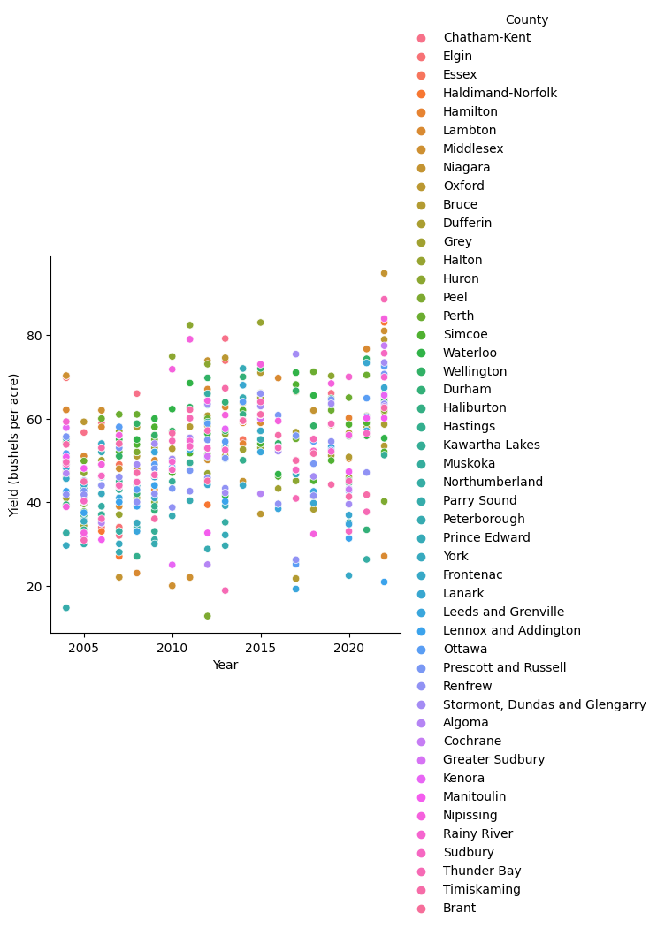

Means from sample data was used to replace missing data: this created a narrow distribution of data points for years where that technique was used.

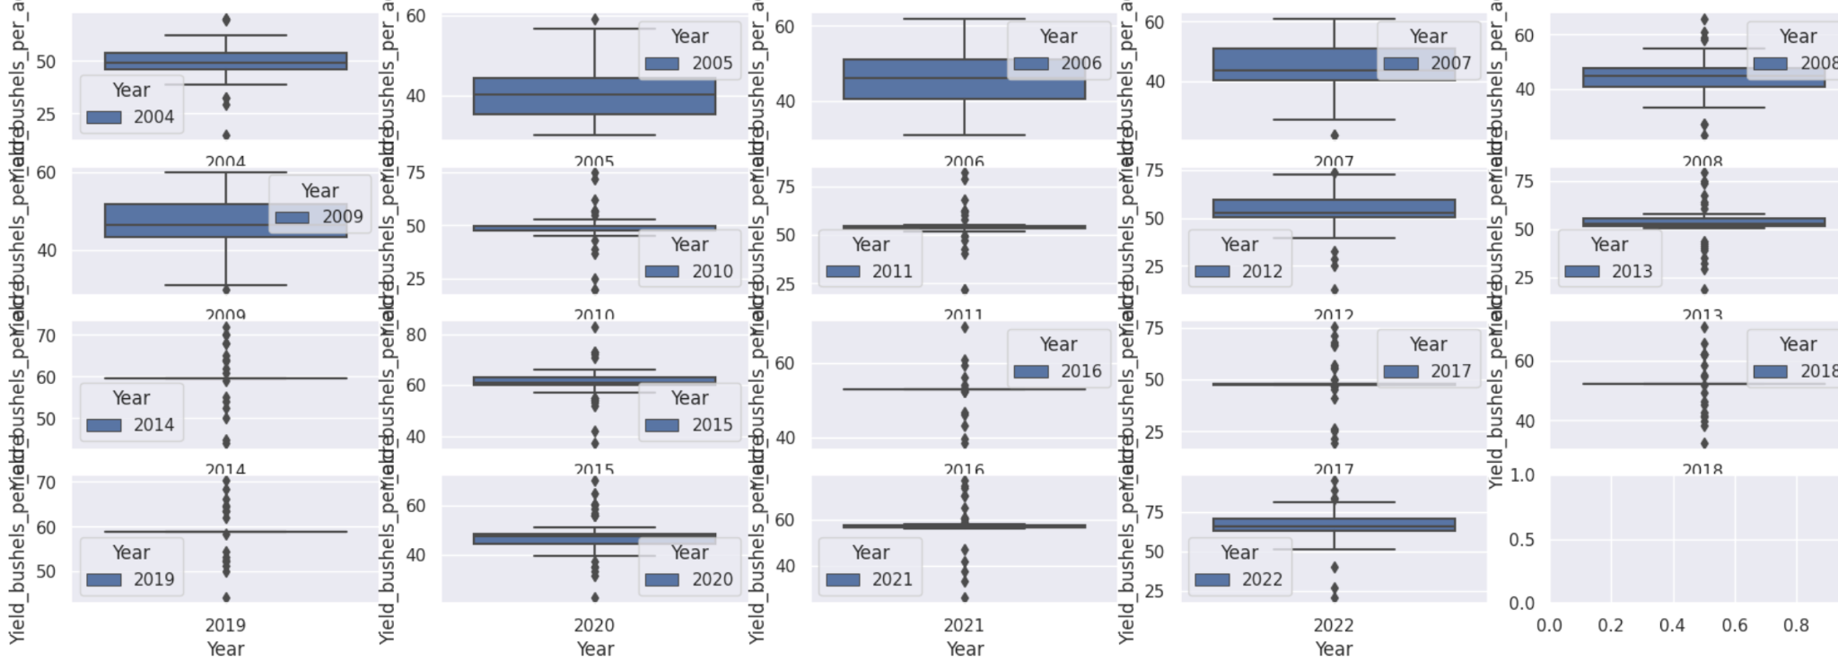

Consequently, for the purpose of the analysis undertaken in this study, only the following years were used: 2004, 2005, 2006, 2007, 2008 and 2009.

Outliers were stripped from each year's crop data (by eliminating data points outside of the range going from the first to the third quartile of each year’s data distribution).

Resulting in the following data shown below

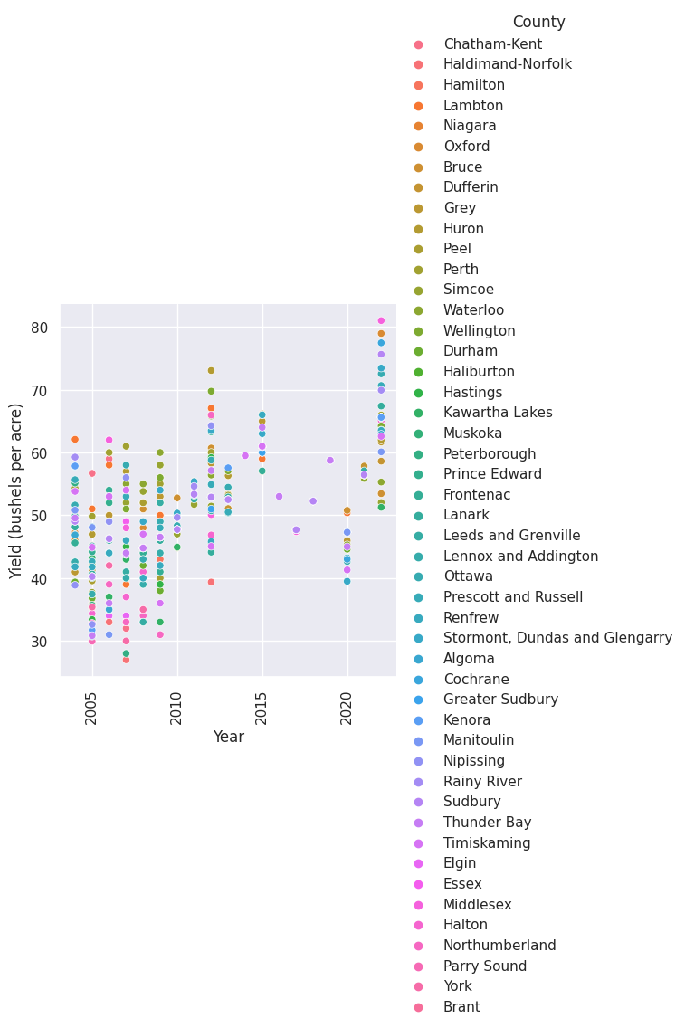

The overall maximum temperature mean looks as follows for the period under study (2004-2023)

| Year | Mean maximum temperature (o Celsius) |
| --- | --- |
| 2004 | 11.34 |
| 2005 | 12.91 |
| 2006 | 13.35 |
| 2007 | 11.92 |
| 2008 | 11.60 |
| 2009 | 11.46 |
| 20010 | 13.22 |
| 2011 | 11.88 |
| 2012 | 13.87 |
| 2013 | 11.80 |
| 2014 | 11.23 |
| 2015 | 12.54 |
| 2016 | 14.07 |
| 2017 | 13.33 |
| 2018 | 12.29 |
| 2019 | 11.76 |
| 2020 | 12.88 |
| 2021 | 13.78 |
| 2022 | 12.60 |

While there is a general upward trend with the maximum temperature mean during 2004 and 2022. There are upward and downward variations during that period.

With weather data, since it would stand to reason that conditions on the ground for counties with a more evenly spread weather station, would be a closer match to those weather station data - it made more sense to use South West Ontario counties rather than all counties (in Ontario).

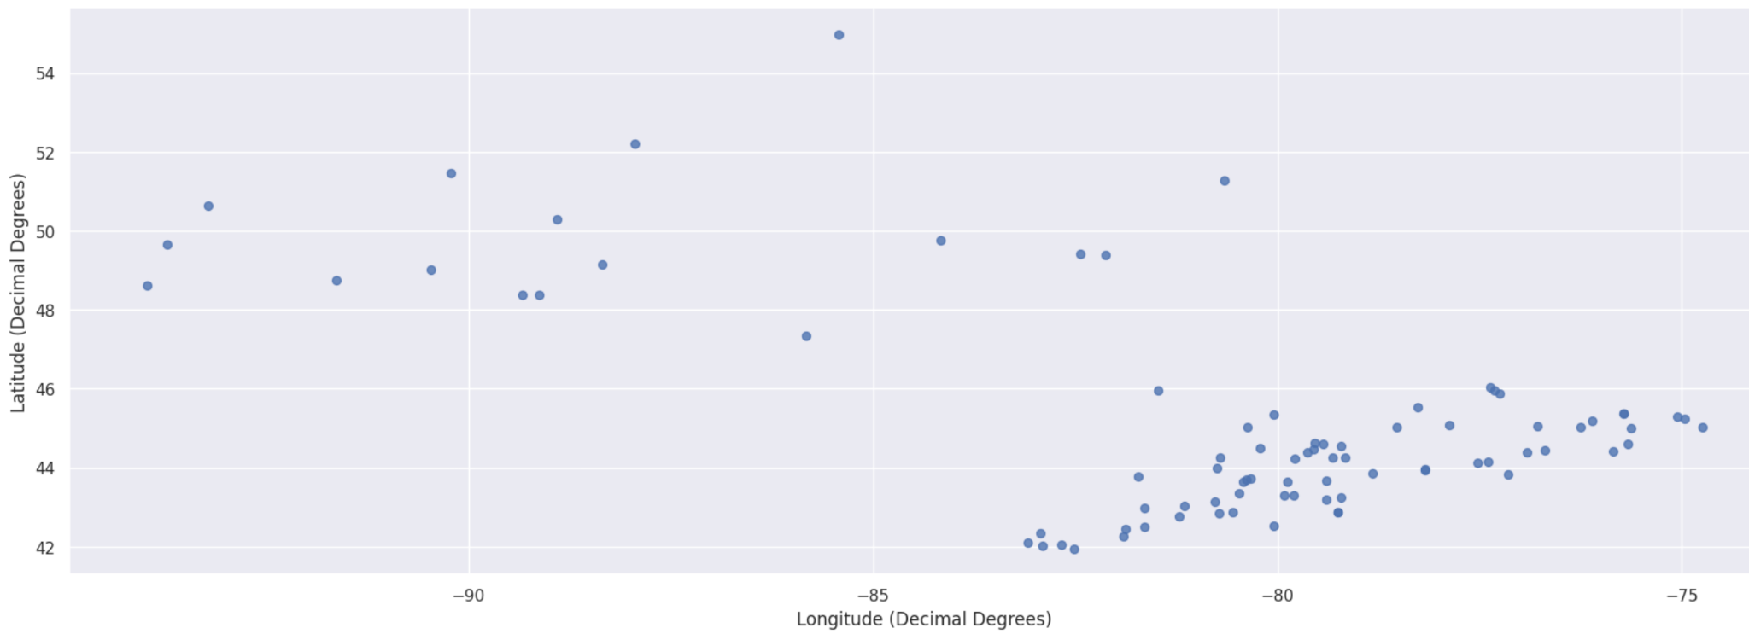

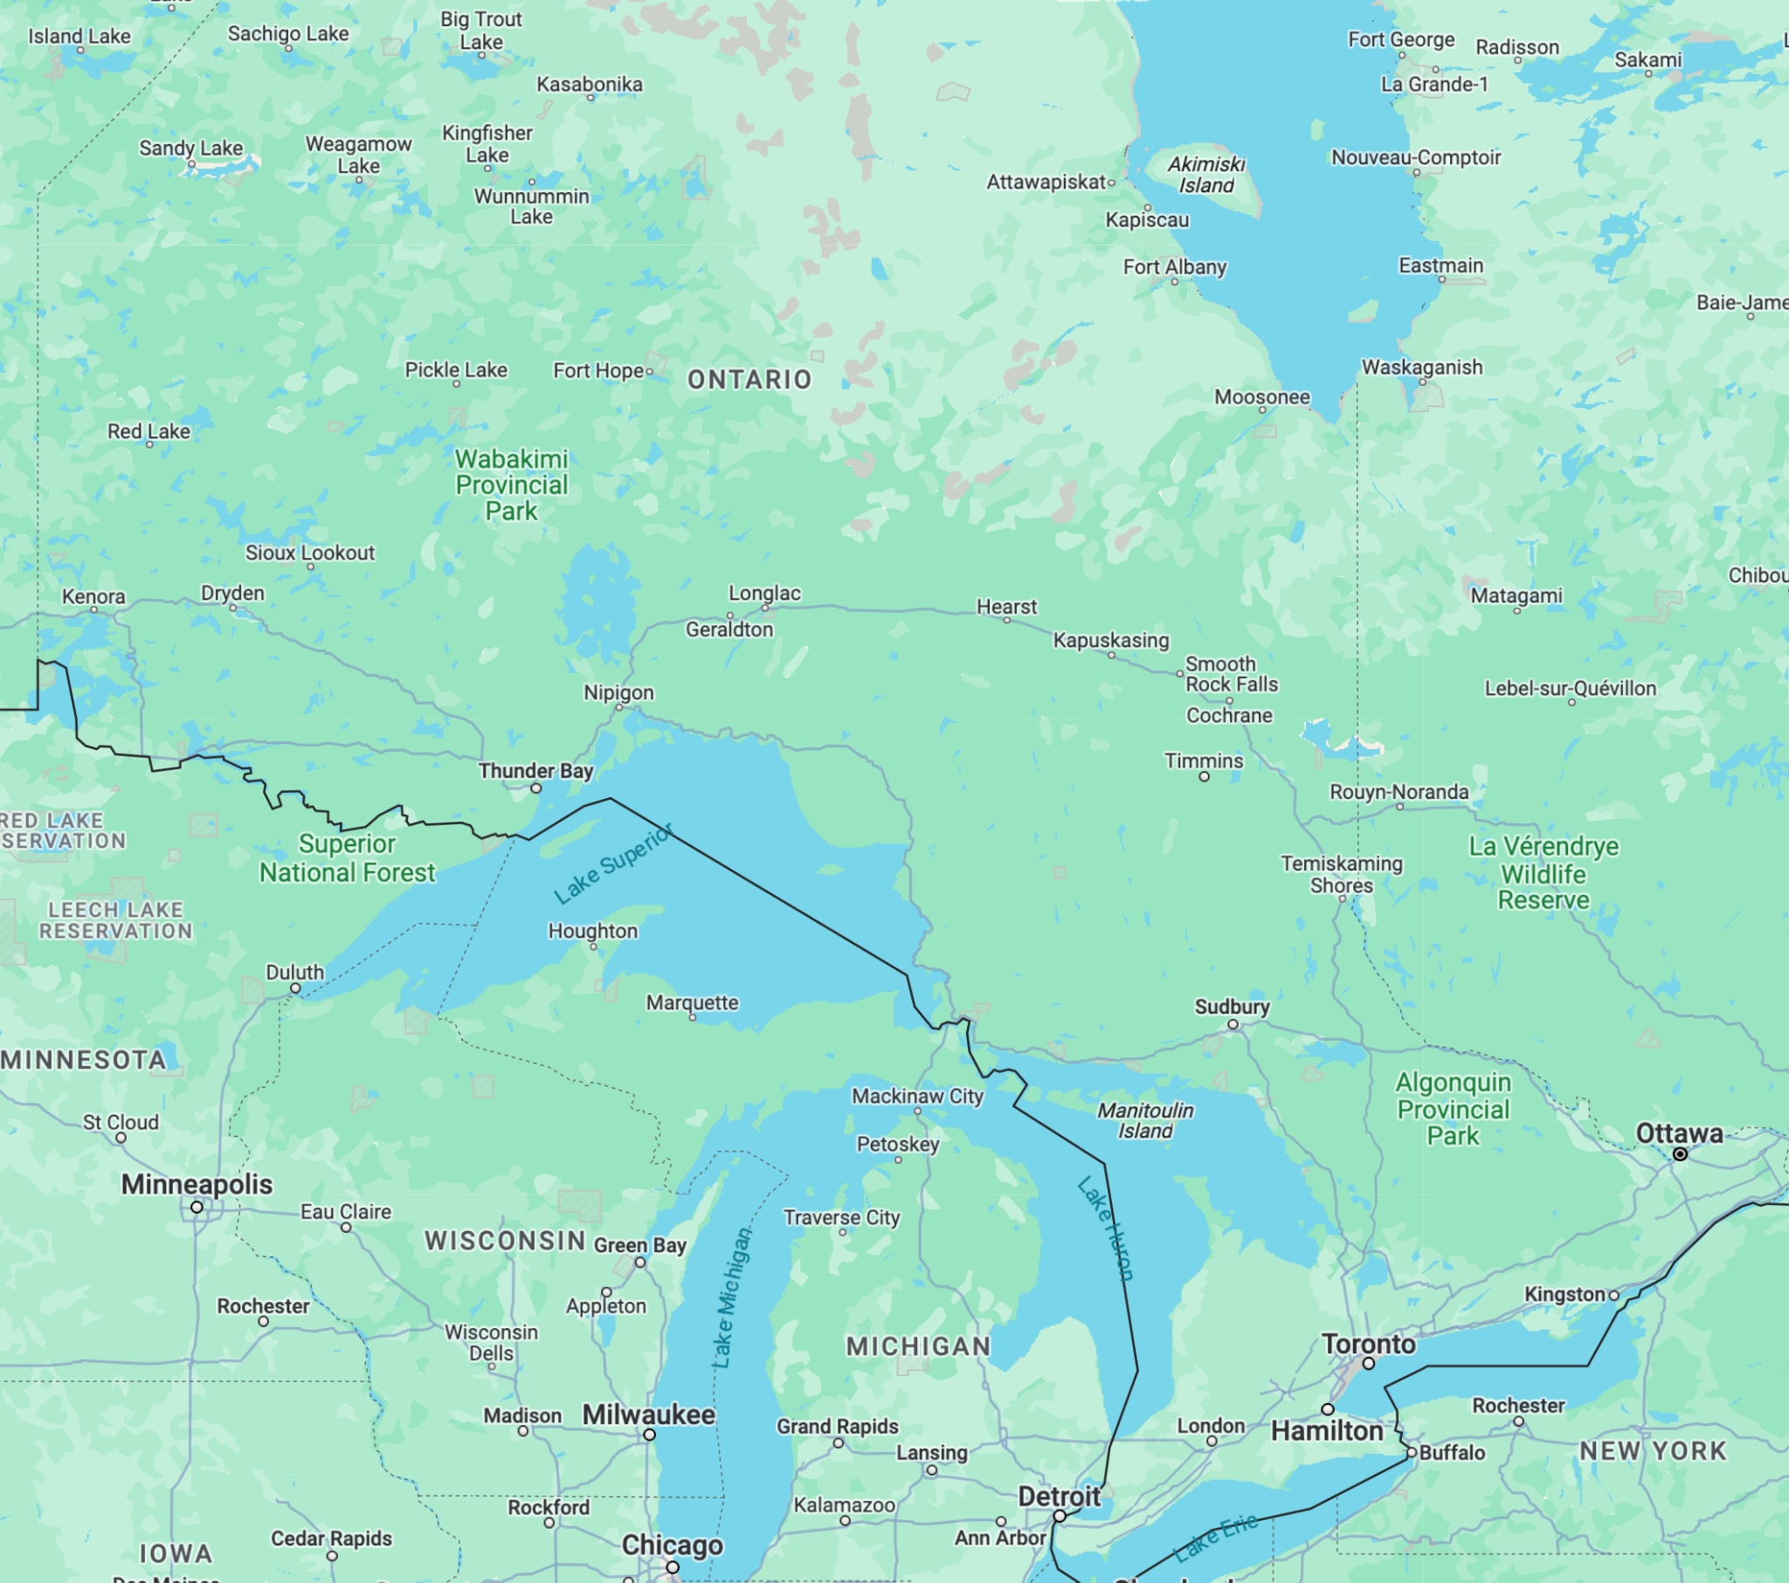

Map of Ontario (Source: Google Maps)

Based on the limited results obtained through this project, it would appear as though a multivariate linear regression can be used to extrapolate Spring wheat yield using maximum temperature and precipitation.

There seems to be some correlation between temperature, precipitation and Spring crop yield, with precipitation having a higher correlation than temperature (as shown in the table below).

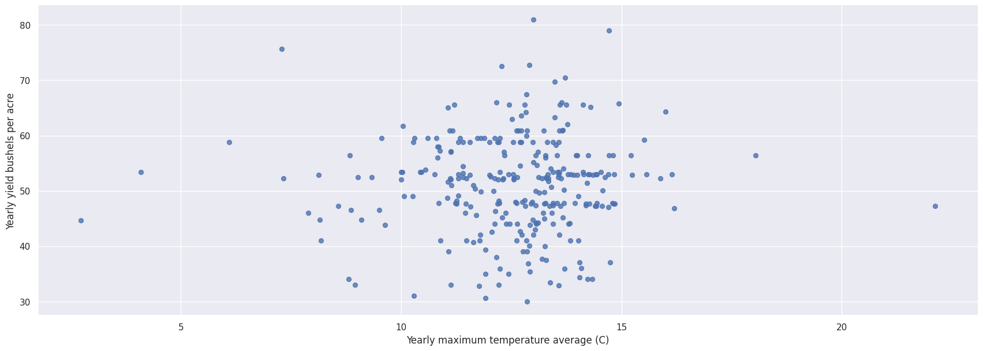

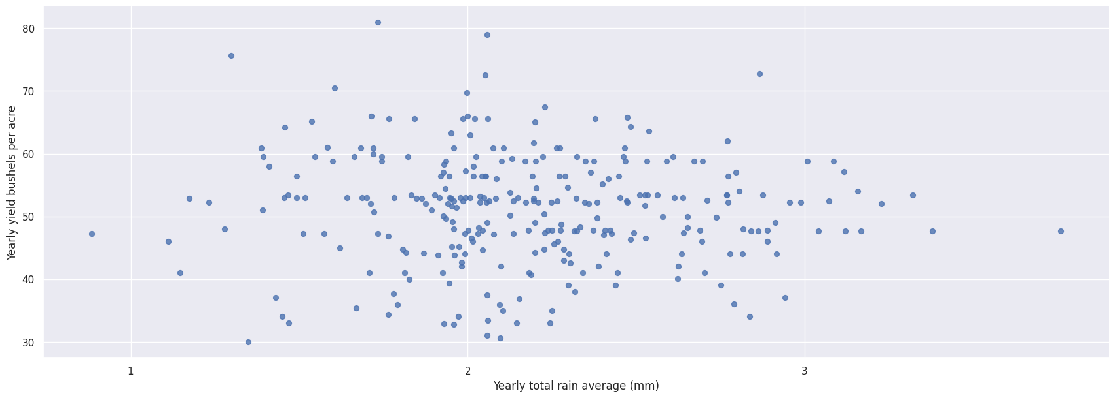

## Correlation Table

|  | Yearly maximum temperature average (o Celsius) | Yearly total rain average (mm) | Yearly yield (bushels per acre) |
| --- | --- | --- | --- |
| Yearly maximum temperature average (o Celsius) | 1.000000 | 0.665556 | 0.019948 |
| Yearly total rain average (mm) | 0.665556 | 1.000000 | -0.031880 |
| Yearly yield (bushels per acre) | 0.019948 | -0.031880 | 1.000000 |

Two folds were used to test a multivariate linear regression algorithm (where the independent variables were maximum temperature and precipitation while crop yield was the dependent variable):

* Year 2004 and 2005 used to train a model to predict year 2006 Spring Wheat crop yield
* Year 2007 and 2008 used to train a model to predict year 2009 Spring Wheat crop yield

RMSE for the year 2006 was ~6.76 while for the year 2009 it was ~7.61[1].

## Conclusions

There are indications of correlation and linearity between temperature, precipitation with crop yield. With the relationship between crop yield and precipitation being the strongest. That is in line with the conclusion reached in the literature review by the *Article Climate change impacts and adaptations for wheat employing multiple climate and crop models in Pakistan,* which stated that precipitation is the most important determinant of crop yield… so long that temperatures during the growing season don’t exceed a certain threshold.

With cyclical weather patterns such as El Niño, if they don’t lead to droughts, floods or early flood then their effects would be captured by the particularities of temperature and precipitation data on any given year and thus a linear regression could still be used to calculate crop yields.

With the dataset under study, there were too many periods with scarce crop data. It has impacted this study's ability to perhaps have more folds to evaluate the effectiveness of linear regression (or any other methodology) to help predict the relationship between wheat crop yield and temperature and/or precipitation. Nevertheless, with the results two-fold cross validation of a multivariate linear regression seems to indicate that it is a promising avenue to such an algorithm to predict crop yield.

It stands to reason that a linear regression can be applied in scenarios where neither droughts, floods nor early frosts are present. A more robust tool for predicting Spring Wheat would need to assess those conditions.

# References

Lobell,David B.; Gourdjil, Sharon M..The Influence of Climate Change on Global Crop Productivity. Plant Physiology, Vol. 160, No. 4 (December 2012), pp. 1686-1697 (12 pages). <https://www.jstor.org/stable/41812017>

Chen, Yi; Zhang, Zhao; Fulu Tao; Impacts of climate change and climate extremes on major crops productivity in China at a global warming of 1.5 and 2.0 °C. Earth System Dynamics; Gottingen Vol. 9, Iss. 2, (2018): 543-562. <http://ezproxy.lib.torontomu.ca/login?url=https://www.proquest.com/scholarly-journals/impacts-climate-change-extremes-on-major-crops/docview/2040734586/se-2?accountid=13631>

Chen,Yongfu; Wu,Zhigang; Okamoto, Katsuo; Han, Xinru; Ma, Guoying; Chien, Hsiaoping; Zhao, Jing. The impacts of climate change on crops in China: A Ricardian analysis. Global and Planetary Change, Volume 104, May 2013, Pages 61-74. <https://doi-org.ezproxy.lib.torontomu.ca/10.1016/j.gloplacha.2013.01.005>

EITZINGER, J. ; TRNKA,M. ; SEMERÁDOVÁ, D. ; THALER, S.; SVOBODOVÁ, E. ; HLAVINKA,P. ;ŠIŠKA, B. ;TAKÁČ, J. ;MALATINSKÁ, L. ;NOVÁKOVÁ, M. .Cambridge University Press: 09 October 2012. Regional climate change impacts on agricultural crop production in Central and Eastern Europe – hotspots, regional differences and common trends. <https://www-cambridge-org.ezproxy.lib.torontomu.ca/core/journals/journal-of-agricultural-science/article/regional-climate-change-impacts-on-agricultural-crop-production-in-central-and-eastern-europe-hotspots-regional-differences-and-common-trends/86F7A151F526C094356F2C3F9A501FA8#>

Hussain, J., Khaliq, T., Asseng, S. et al. Climate change impacts and adaptations for wheat employing multiple climate and crop models in Pakistan. Climatic Change 163, 253–266 (2020). <https://doi-org.ezproxy.lib.torontomu.ca/10.1007/s10584-020-02855-7>. <https://rdcu.be/doAjc>

Qian,Budong; De Jong, Reinder ; Yang,Jingyi; Wang,Hong ; Gameda, Sam. Comparing simulated crop yields with observed and synthetic weather data. Agricultural and Forest Meteorology. Volume 151, Issue 12, 2011, Pages 1781-1791, ISSN 0168-1923, <https://doi.org/10.1016/j.agrformet.2011.07.016>. (<https://www.sciencedirect.com/science/article/pii/S0168192311002516>)

Google. (n.d). [Google map of Ontario]. Retrieved November 27, 2023 from <https://www.google.com/maps/@52.4048388,-87.2040985,5z?entry=ttu>

# 

# Appendix A - Datasets

1. Ontario Field Crop report listed on <https://data.ontario.ca/dataset/ontario-field-crop-area-and-production-estimates-by-county/resource/16a875b9-5a56-4ad8-ac5b-dc77bde93c6d>, Spring Wheat data available from <https://data.ontario.ca/dataset/e30dc044-5f75-4f33-b63e-6326f8769bea/resource/16a875b9-5a56-4ad8-ac5b-dc77bde93c6d/download/ctyswheat.xlsx> - Wheat production data from 2004 to 2022 across various counties.
2. Historical weather data from the Government of Canada available at <https://climate.weather.gc.ca/historical_data/search_historic_data_e.html> - It will extracted to match the geographical areas and time span of the above mentioned dataset
3. Capstone project repository: <https://github.com/nbessa/CIND820>

1. Excellent when RMSE < 10%

   Good when RMSE is between 10% and 20%

   Fair when RMSE is between 20% and 30%

   Poor when RMSE > 30%